>> G=tf(20,conv(conv([1 0],[1 1]),[1 2]))

Transfer function:
20
-----------------
s^3 + 3 s^2 + 2 s

>> zpk(G)

Zero/pole/gain:
20
-------------
s (s+2) (s+1)

>> rlocus(G)
>> hold on
>> sgrid(0.8,1.33)
>> [K,P]=rlocfind(G)
Select a point in the graphics window

selected_point =

-0.3947 + 0.2799i

K =

0.0263

P =

-2.1993
-0.4003 + 0.2808i
-0.4003 - 0.2808i

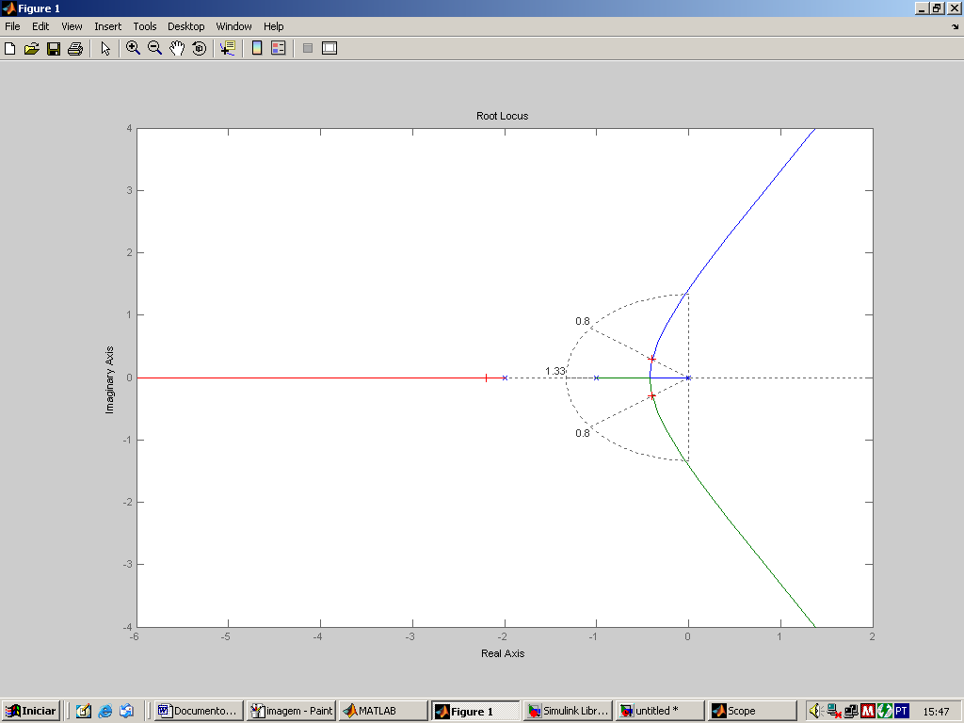

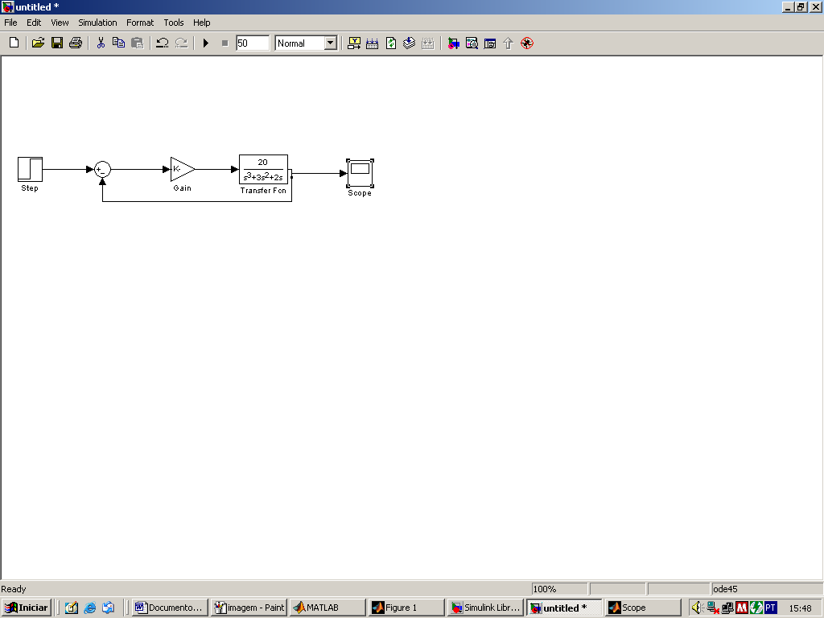

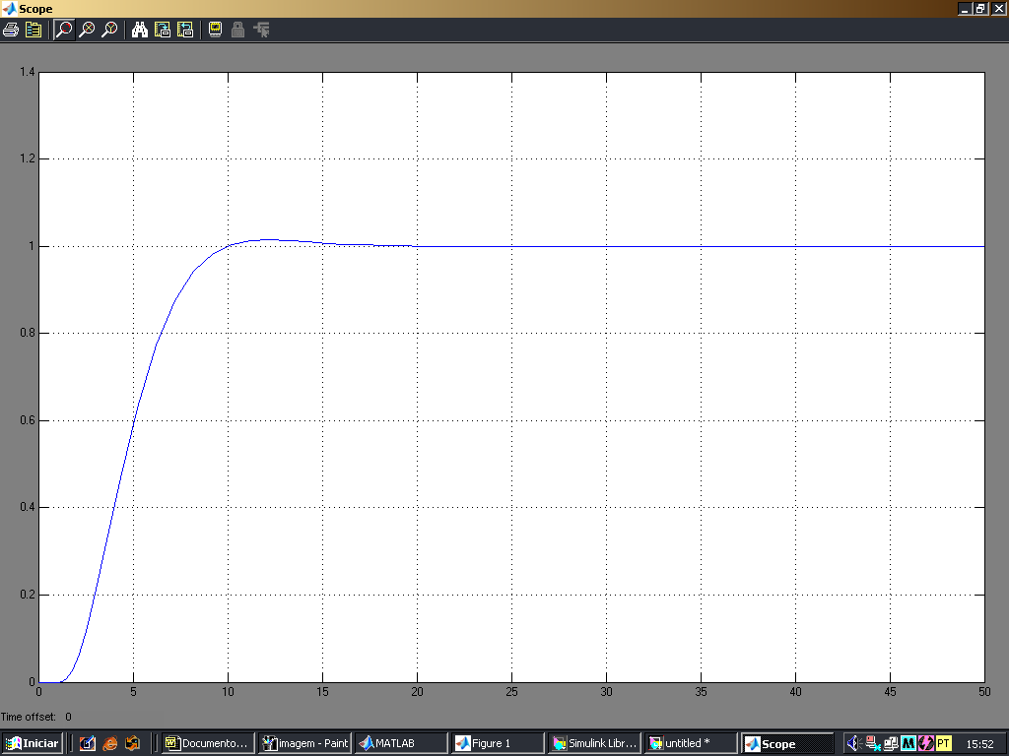

O controlador tipo P resolve o problema para as especificações pedidas.

